# CREATE A STORAGE SERVICE USING ANY PUBLIC CLOUD SERVICE PROVIDER AND ACCESSING FILE

**STEP – 1:**

Create a storage account.

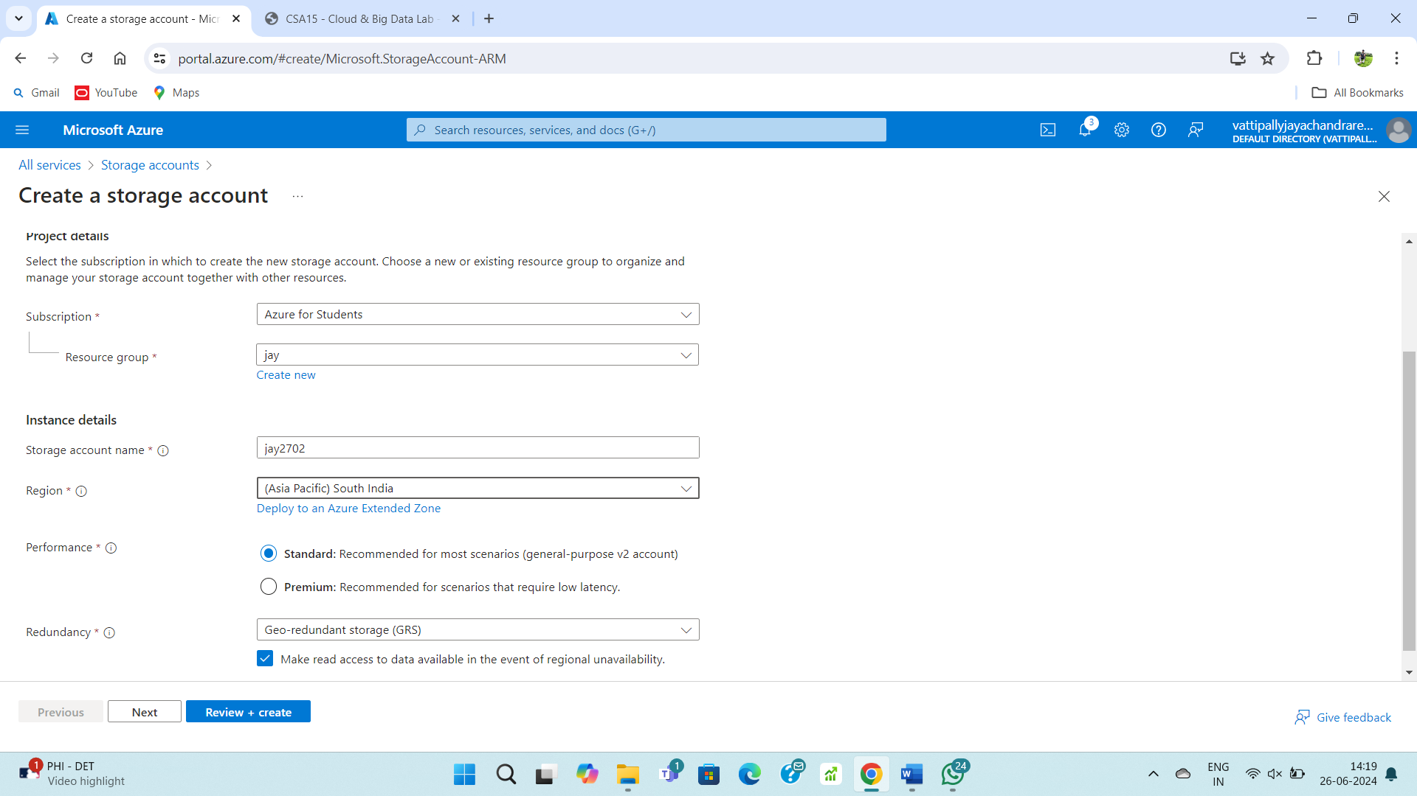

**STEP – 2:**

Fill upon the basics form.

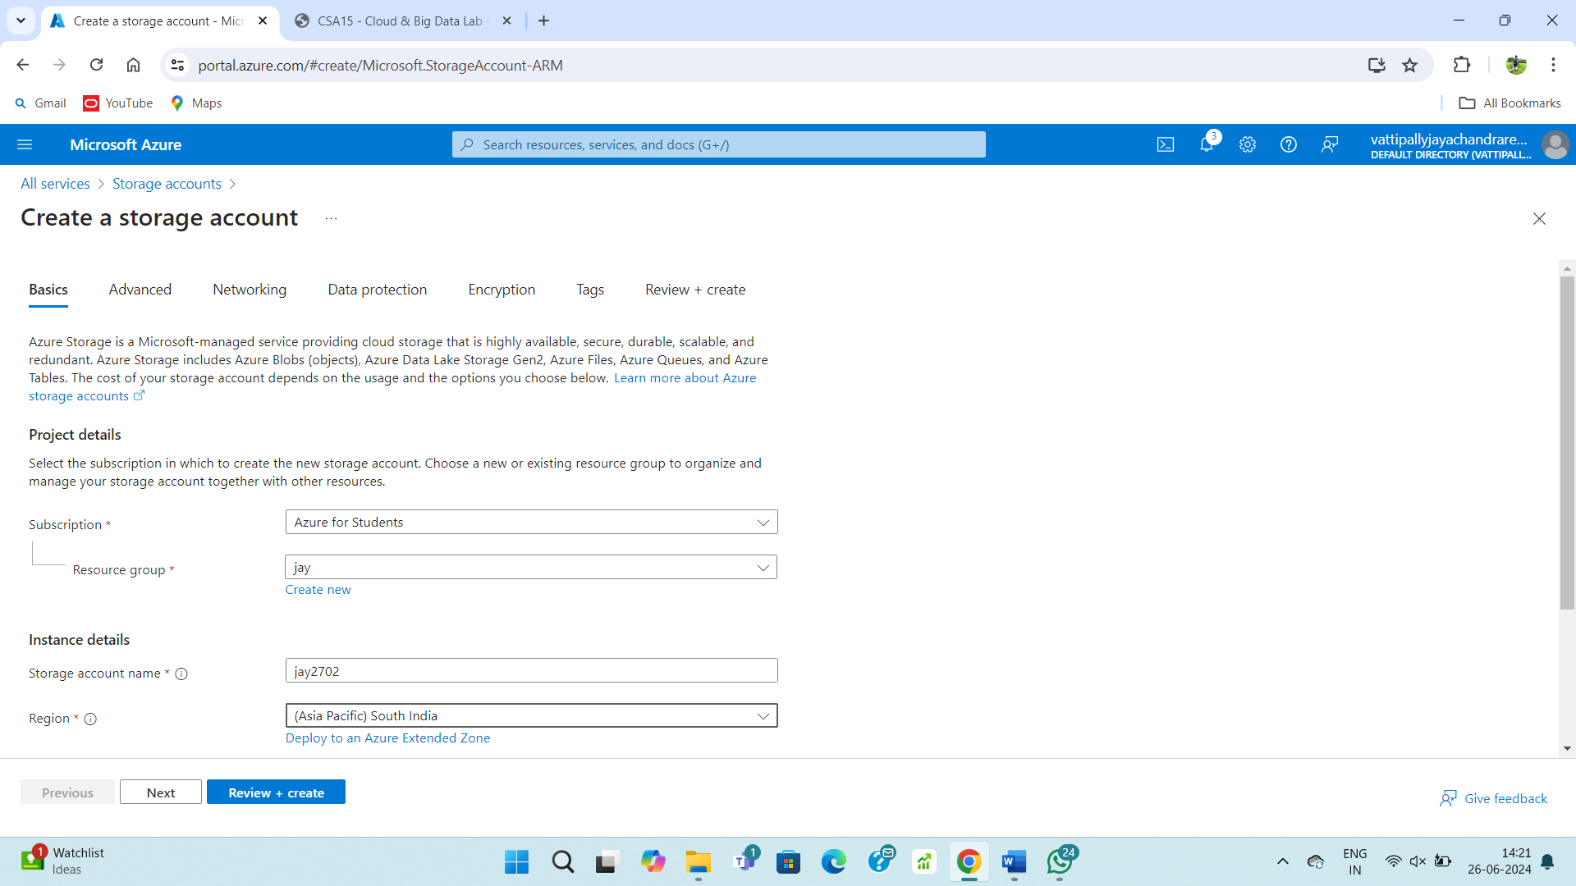

**STEP – 3:**

Fill upon the advanced form.

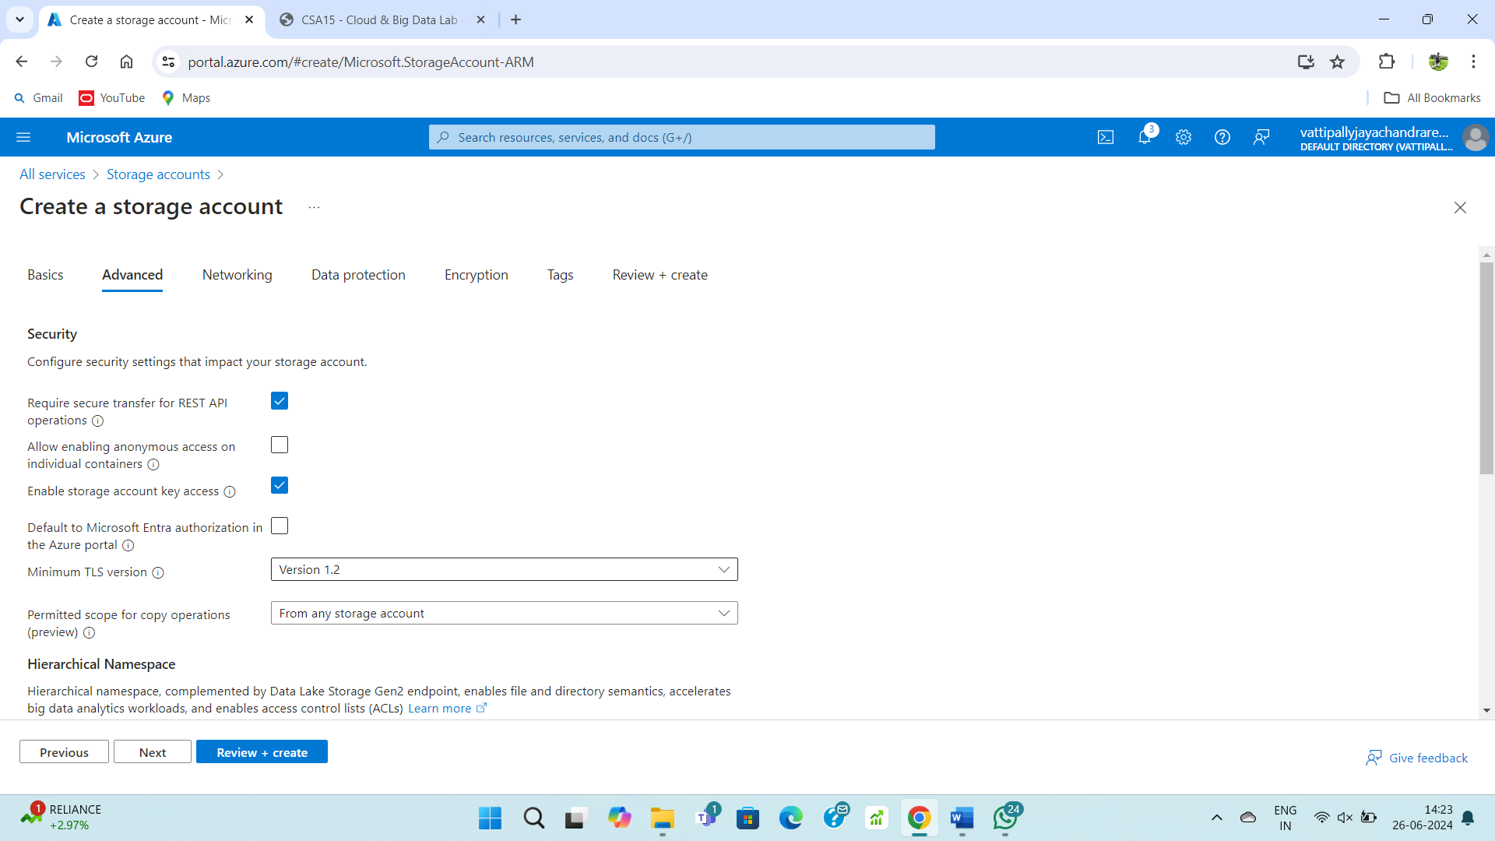

**STEP – 4:**

Fill upon the networking form.

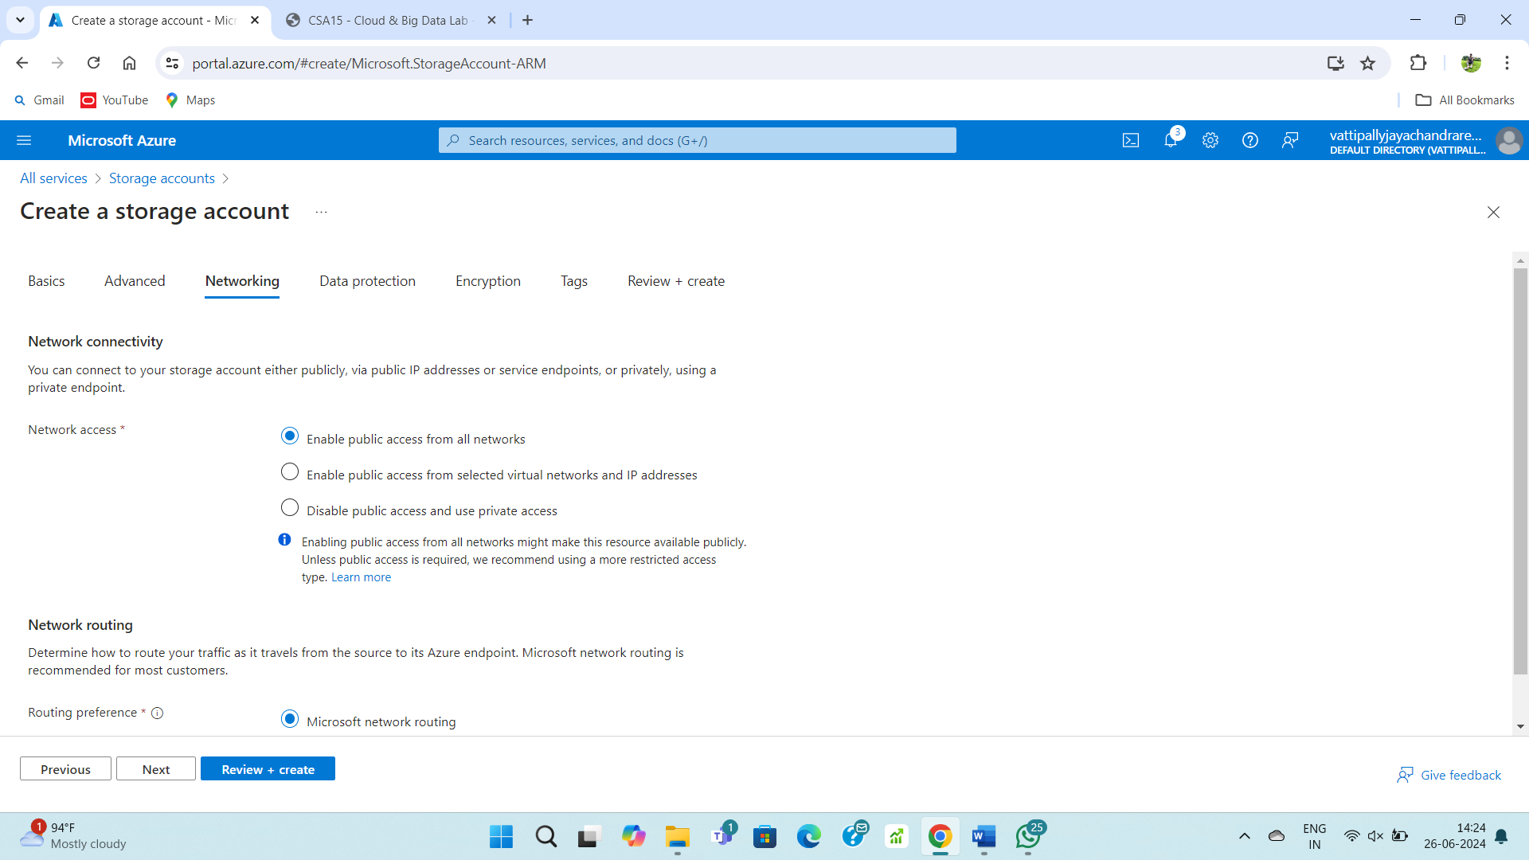

**STEP – 5:**

Fill upon the data protection.

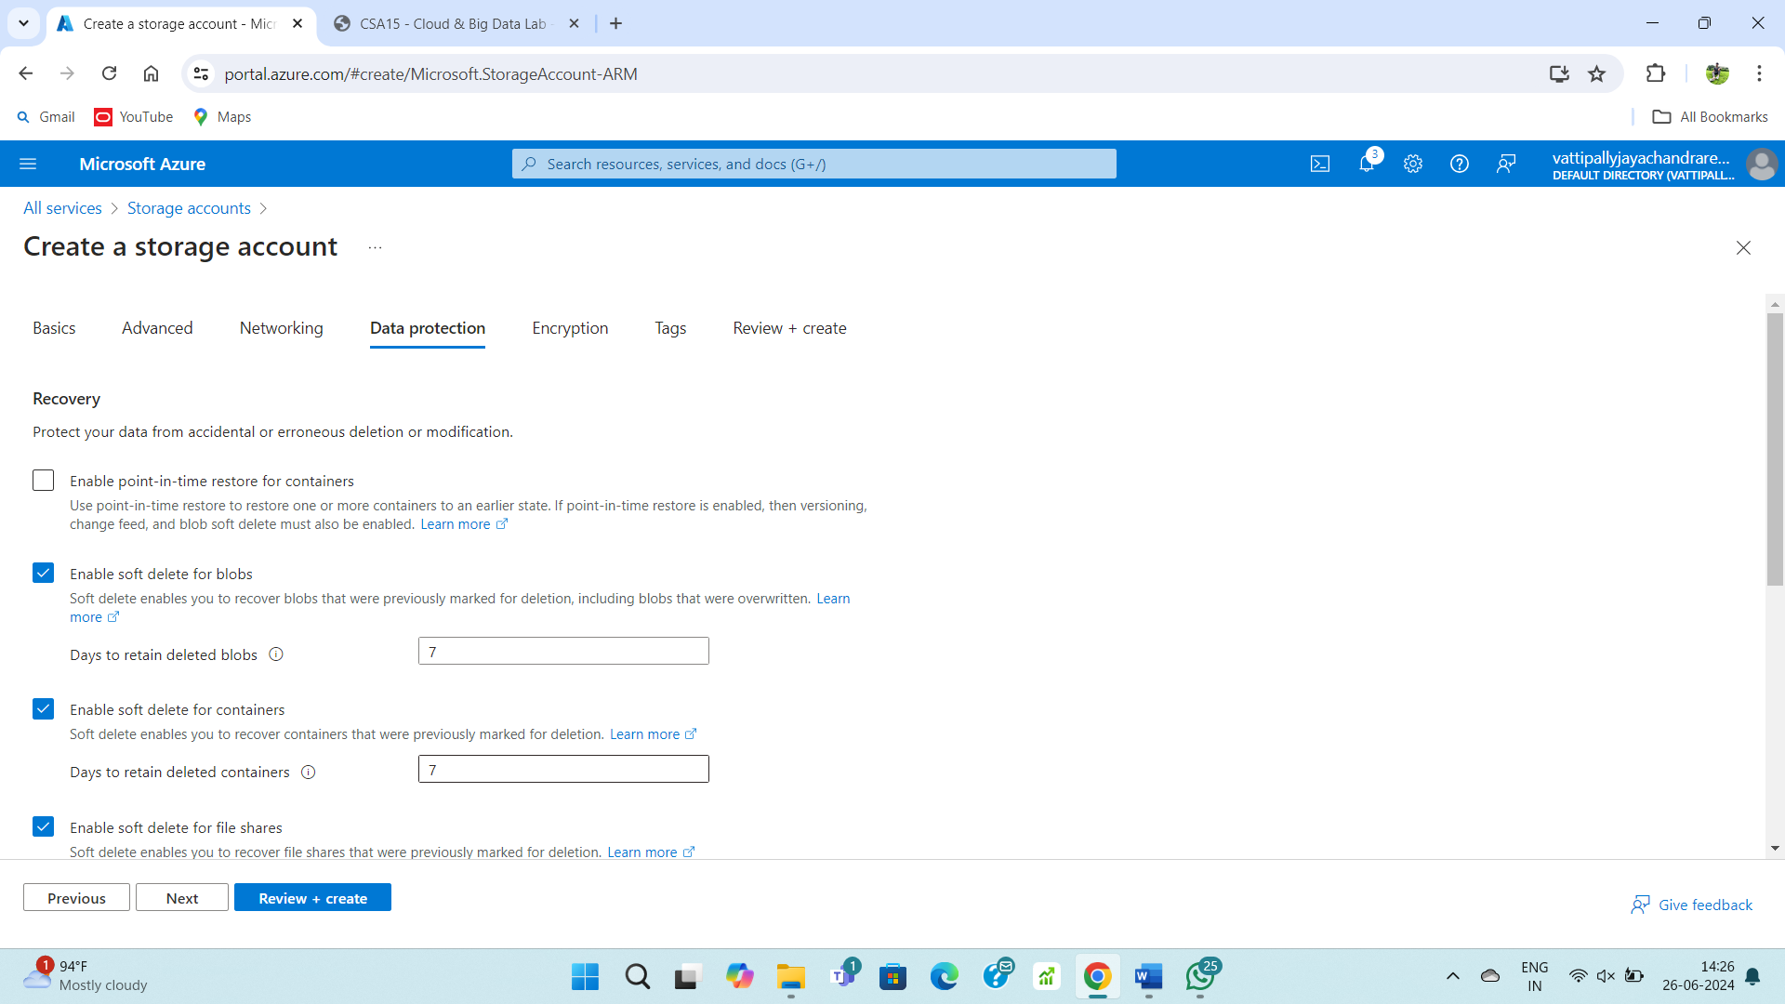

**STEP – 6:**

Fill upon the encryption form.

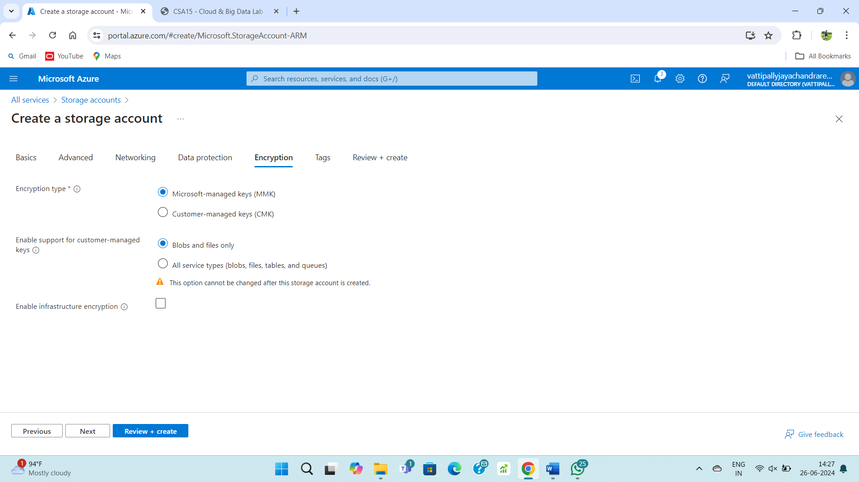

**STEP – 7:**

Fill upon tags form.

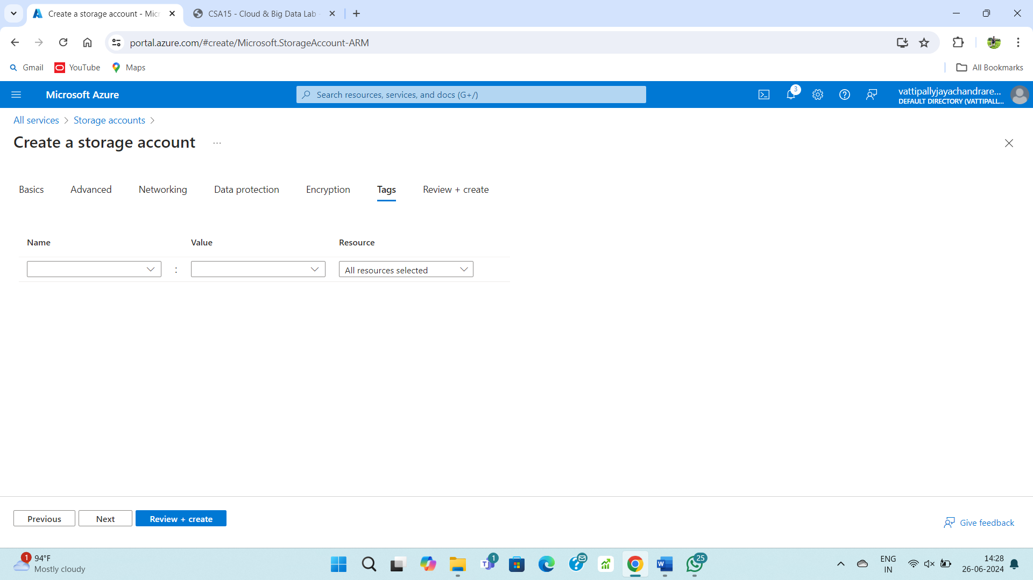

**STEP – 8:**

Review and create the storage account.

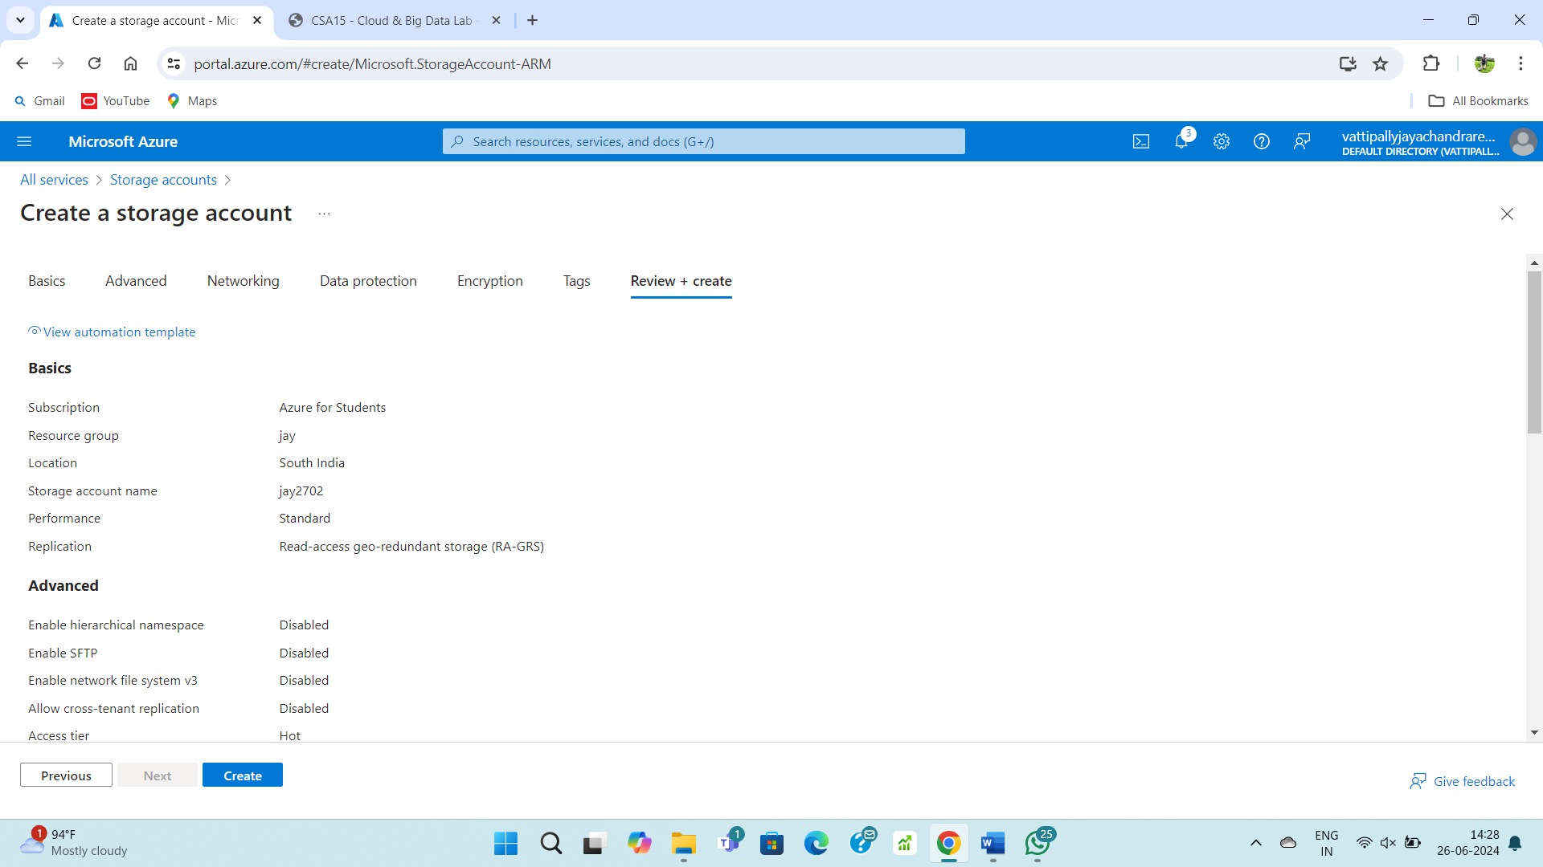

**STEP – 9:**

After deployment your resource is ready.

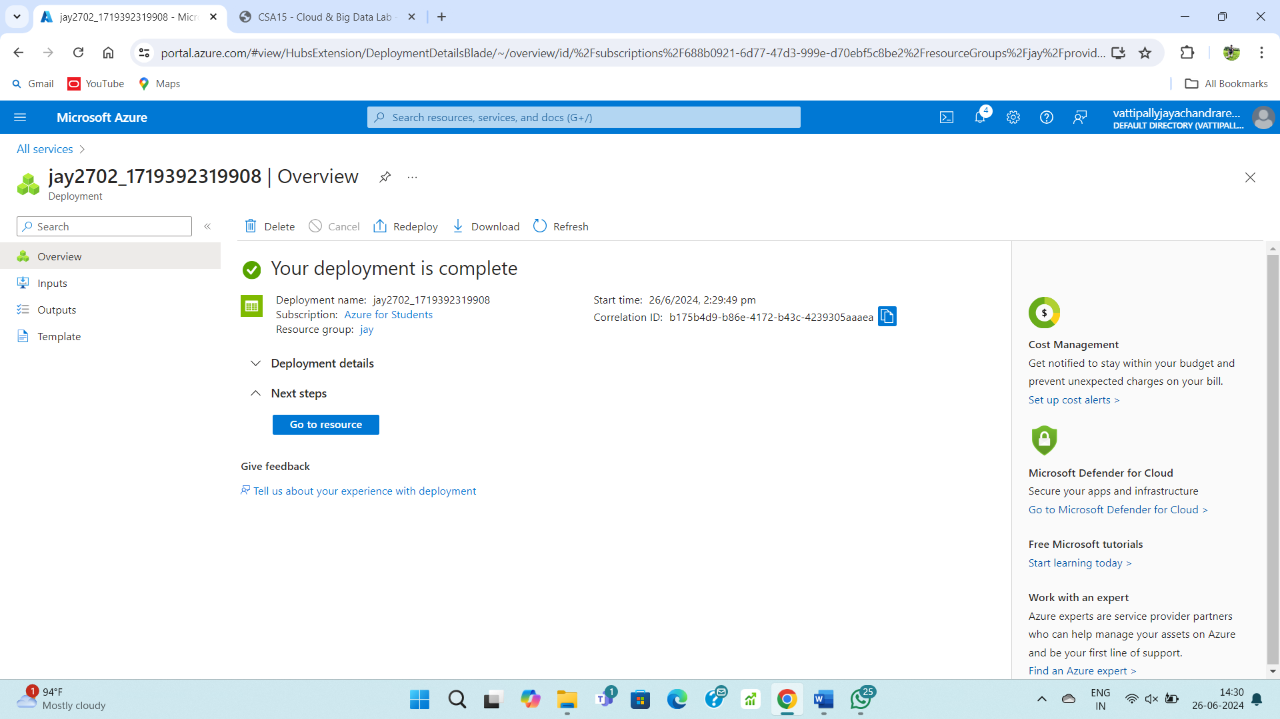

**STEP – 10:**

Upload a file into the storage account.

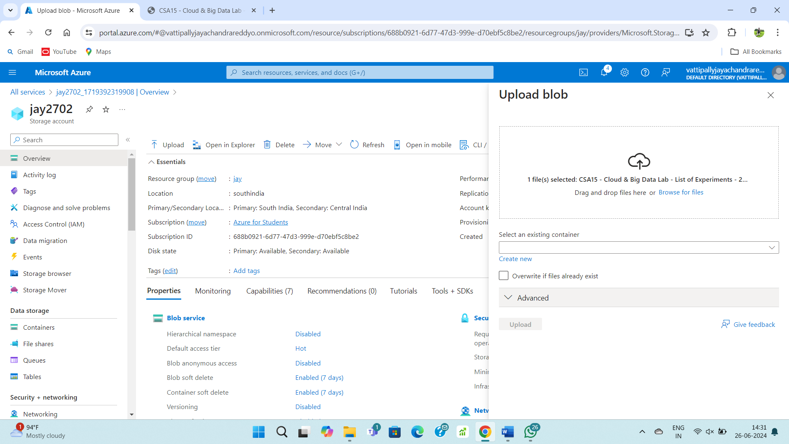

**STEP – 11:**

Your file is ready to use via cloud.

